**GROUP – 3**

**OOP PROJECT REPORT**

**STUDENT ATTENDANCE TRACKER**

**GROUP MEMBERS : -**

1.Akshara P – 19Z305

2.Dhanavandhana K – 19Z311

3.Samyuktha A S K – 19Z343

4.Saranya K – 19Z345

5.Sushmitha S – 19Z352

6.Jaivin K Mehta - 19IZUS011

**STUDENT ATTENDANCE TRACKER**

**Problem Statement:**

Student Attendance Tracker is a software developed to maintain student’s attendance in college. It facilitates to access the attendance information of a particular student in a class.By just a click on the mouse, the system will be able to produce the students' attendance report thus reducing the need for manual labour which is prone to human errors and time consuming.

The main objective to develop the student attendance tracker application is to reduce the work for faculty because they record the attendance manually in notebooks. It is very difficult to maintain the attendance record of the students for entire academic year and calculating the attendance percentages manually.

This project handles two users – student and faculty.The student(Both regular and ias) can only view the attendance record whereas the staff can view as well as modify the attendance record.This application will be very helpful for both student and faculty to keep track on the attendance and we developed the code to calculate the attendance percentage also.This project can be used for a class.This project also validates the input data and prompts mistakes that are made by the user.

**Class Diagram:**

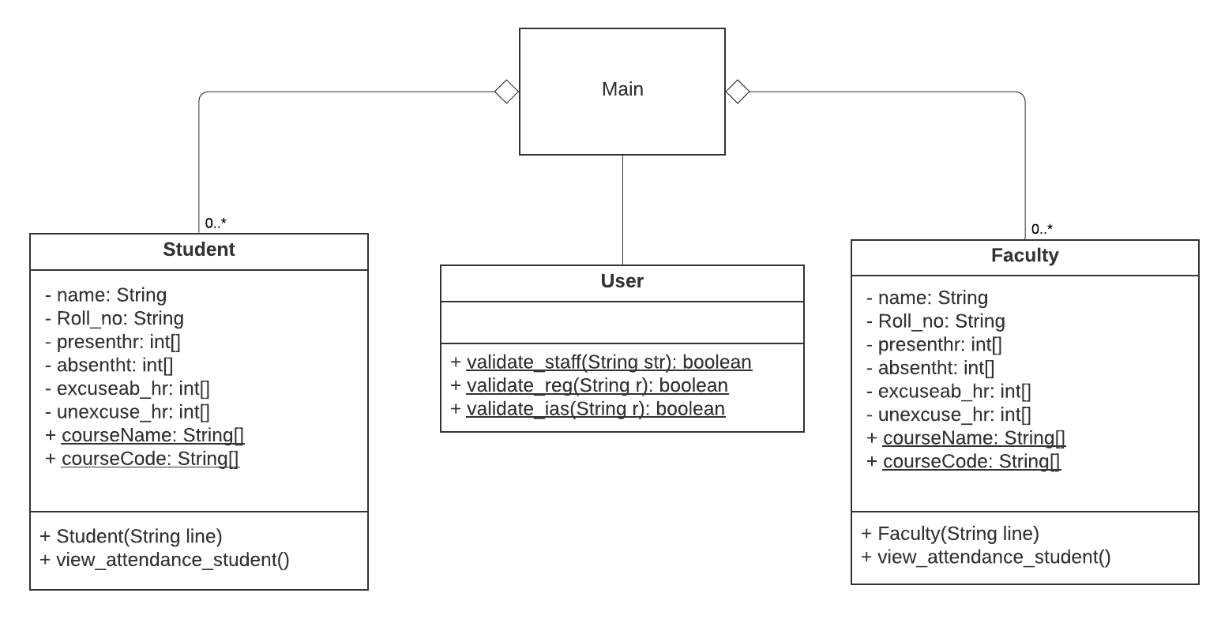**Users and Features available to them in the application:**

**Users:**

1. Student
2. Faculty
3. Admin

**Features available to the users:**

This application can be used by both student and faculty to view the attendance. The application is developed in such a way that the attendance of a student is read from the “Excel file” and based on the input (roll number or course code) given by the user, that particular student’s attendance is displayed as the output.

Students can able to view their attendance in all subjects. But faculty can view attendance only for the subject which they are handling. User must specify the input whether they want to view the attendance for regular or IAS. If the user is a student (regular or IAS) he/she should give the roll number as input and the roll number will be checked whether it is valid or not. If the given roll number is valid then user can view the attendance, otherwise it will throw an exception as “Invalid rollnumber”. If the user is faculty, course code will be given as input and it will be checked whether it is valid or not, if it is valid course code faculty can view the attendance. The admin role provided in the front-end template allows the user to add new students or edit the information about existing ones where attendance percentage is automatically calculated. These updates will also be reflected in the file as well.

This application is developed to view attendance only for three months (August, September and October). So, the user will be asked to enter which month attendance they want to view.

Calculating attendance percentage for all subjects:

Adding present hour, absent hour, excused hour, unexcused hour and store it in total.

Percentage = present hour/total*100.

By this way attendance is calculated for all subjects.

**Contribution of team members:**

19Z305 Akshara P 🡪 class Faculty

19Z311 Dhanavandhana K 🡪 Back end

19Z343 Samyuktha A S K 🡪 class Student

19Z345 Saranya K 🡪 class Faculty

19Z352 Sushmitha S 🡪 Front end

19IZUS011 Jaivin K Mehta 🡪 Report

**Challenges Faced:**

We used scanner class to read the csv file line by line. But we are able to read only the first line of the csv file. The rest of the lines of the file were not read. Then we used “BufferReader” class to read the csv file line by line. After using BufferReader class, we were able to read each and every line of the file. This is the challenge we faced while doing this project. From this we came to know that Scanner class has little buffer when compared to BufferReader class.

**SNAPSHOTS OF OUTPUT:**

**STUDENT:**

**1.REGULAR**

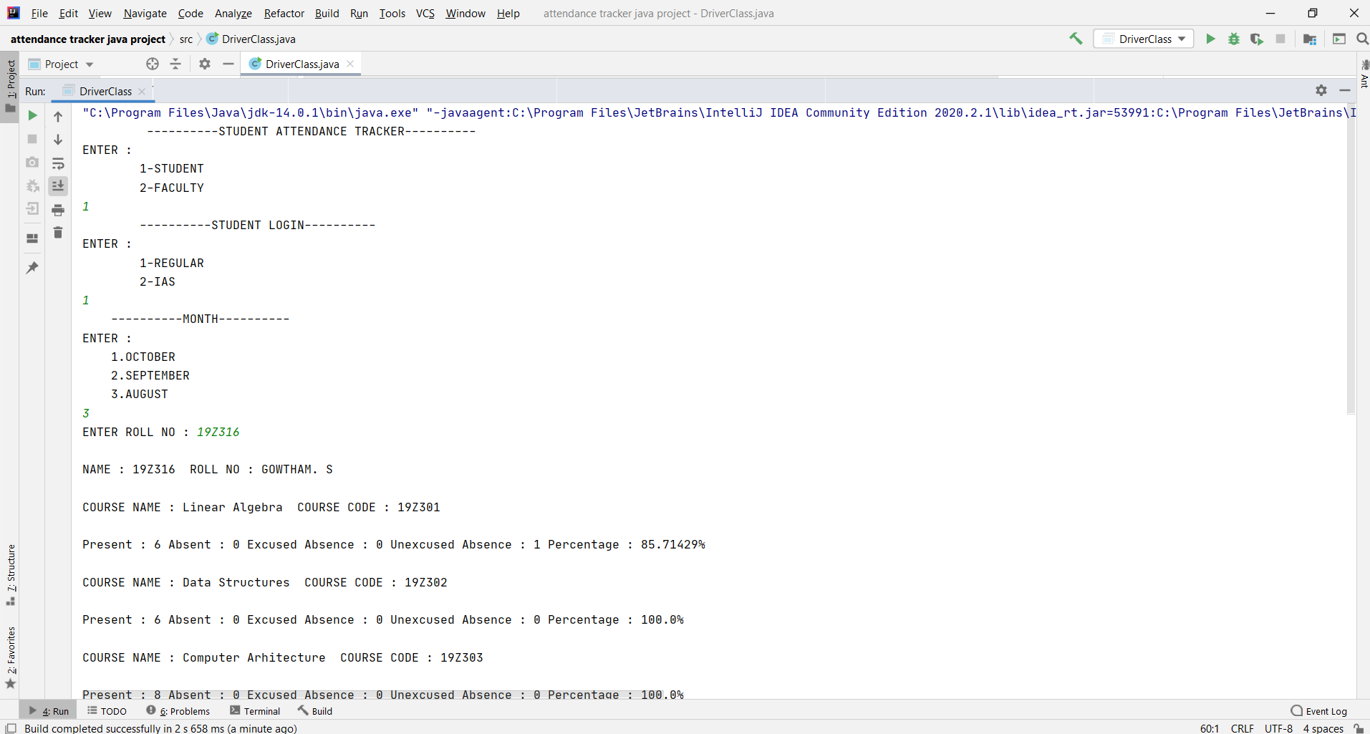

**2.IAS**

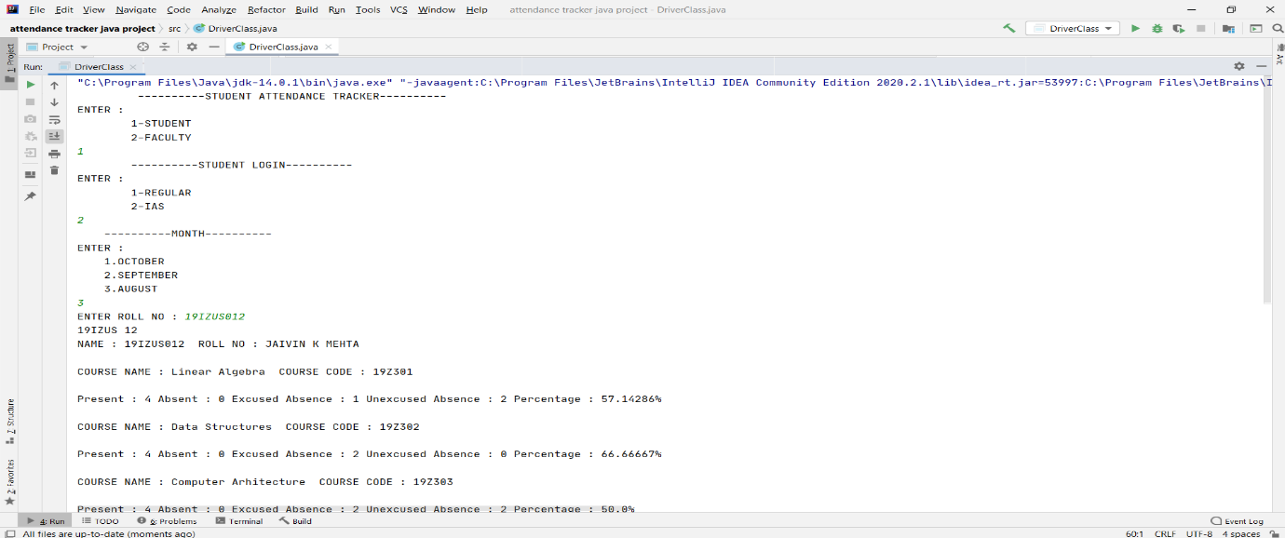

**FACULTY:**

**1.REGULAR**

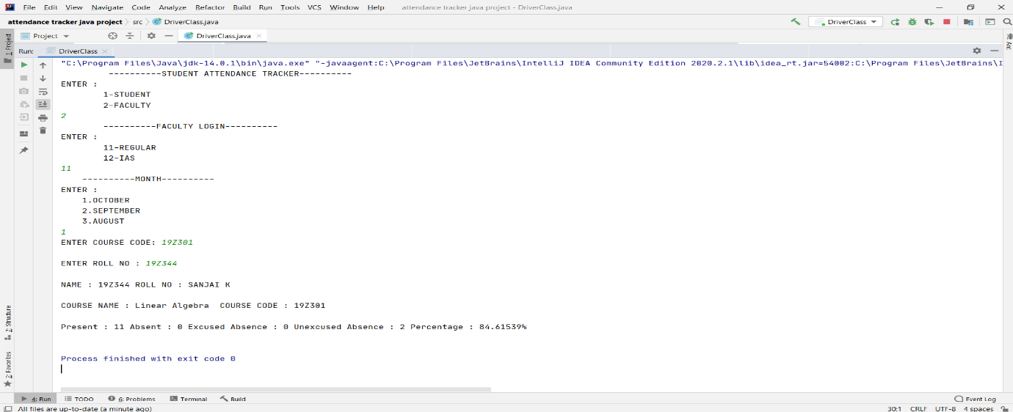

**References:**

1. <http://www.java2s.com/Tutorial/Java/0240__Swing/Catalog0240__Swing.htm>
2. <https://docs.oracle.com/javase/tutorial/uiswing/index.html>
3. “Java: The Complete Reference” by Scildt H

**PLAGIARISM REPORT SCREENSHOT :**

